MAE 263F Proposal
Ursa Z., University of California Los Angeles
Abstract— We will use the Discrete Element Method (DEM) to design a soft robotic segment whose stiffness can be tuned on demand via a granular-jamming sleeve. A bonded-particle DEM (for the soft core) will be coupled to free particles (for the sleeve) so the same solver models body elasticity, jamming, and contact with objects. We will optimize micro-level parameters (bond stiffness, bead size, packing fraction, vacuum level) for accurate tip positioning and stable grasps.

Problem Statement & Motivation

Soft robots are safe and adaptable but are often too compliant to carry loads or hold shape precisely. Granular jamming increases stiffness, yet current designs are trial-and-error. We need a fast, predictive simulation to choose particle sizes, packing, and actuation that deliver both dexterity (unjammed) and rigidity (jammed).

background
The discrete (or distinct) element method originated to simulate interacting particles with explicit time integration and contact laws; it has become a standard for granular and particulate media. Bonded-particle extensions (BDEM) connect particles with breakable elastic bonds, allowing continuum-like elastic behavior and fracture to emerge from micro-mechanics. Classic references include Cundall & Strack (1979) and Potyondy & Cundall (2004). Recent work (e.g., Celigueta et al., 2017) refines contact/bond laws to better reproduce continuum elasticity without heavy calibration.
Landscape reviews (Rus & Tolley, 2015; Polygerinos et al., 2017) emphasize compliant materials, fluidic actuation, and safe interaction, but most simulation tools rely on FEM, Cosserat-rod models, or MPM; differentiable MPM (ChainQueen) enables gradient-based co-design but uses a continuum field discretization. DEM has been under-used for robot body + granular skin + environment in one solver, despite its natural handling of contact, frictional dissipation, and jamming. Our work complements MPM/FEM by exploiting DEM’s particle nature for both structure and environment and by capturing rearrangements/jamming without additional constitutive switching.
The universal jamming gripper established that a bed of grains can conform to objects and, upon vacuum, harden to provide strong holds through friction, suction, and interlocking. Yet predictive, geometry-aware parametric design remains limited. DEM is well-suited to analyze how particle size distributions, confinement geometry, and vacuum-induced pressure translate into macroscopic stiffness and holding forces.
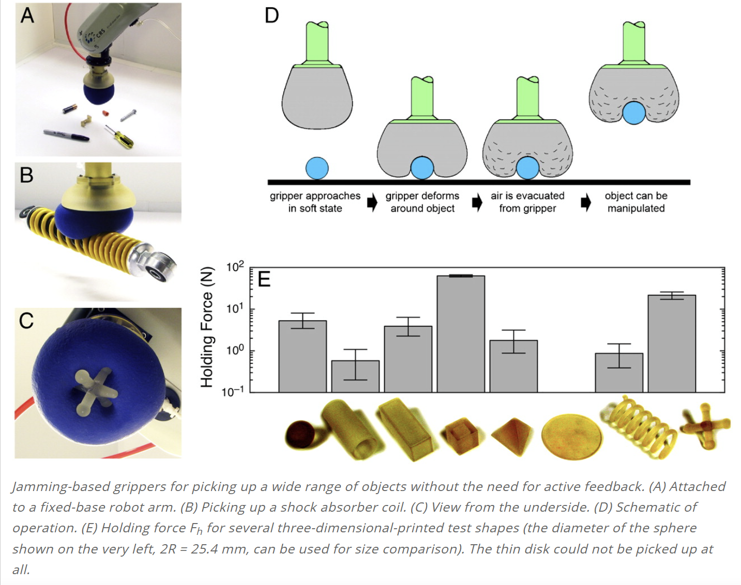

proposed approach
Robot concept: a 10–20 cm soft segment with:
Core: bonded-particle DEM lattice (Kelvin-Voigt bonds) calibrated to target 𝐸 and damping.
Sleeve: unbonded beads inside a thin membrane; vacuum causes jamming.
Actuation: cable pair (or two pneumatic chambers) for planar bending.

Simulation plan:
Calibrate core bonds to match small-strain modulus and bending response.
Sweep sleeve parameters (bead radius/polydispersity, packing fraction, vacuum pressure).
Run tasks: tip set-point tracking; grasp and lift irregular objects; insertion into loose grains.
Optimize (multi-objective) for low tip error, high grasp margin, and low energy.

References
1] P. A. Cundall and O. D. L. Strack, “A discrete numerical model for granular assemblies,” Géotechnique, 1979.
[2] D. O. Potyondy and P. A. Cundall, “A bonded-particle model for rock,” Int. J. Rock Mech. Min. Sci., 2004.
[3] E. Brown et al., “Universal robotic gripper based on the jamming of granular material,” PNAS, 2010.
[4] D. Rus and M. T. Tolley, “Design, fabrication and control of soft robots,” Nature, 2015.
[5] Y. Hu et al., “ChainQueen: A real-time differentiable physical simulator for soft robotics,” ICRA, 2019.
[6] C. O’Sullivan, Particulate Discrete Element Modelling, CRC Press, 2011.

